Rossmann Store Sales Forecasting using Machine Learning and Deep Learning

Introduction
Sales forecasting is a critical task for retail businesses as it helps in inventory planning, staffing, promotions, and financial forecasting. Rossmann Pharmaceuticals operates multiple stores across different cities, and predicting daily sales accurately can help management take better business decisions.
In this project, the objective is to forecast daily sales for Rossmann stores up to six weeks ahead using historical data. The challenge involves understanding customer purchasing behaviour, handling time-based features, building robust machine learning and deep learning models, and finally deploying the trained model as a web application for business users.
The project follows an end-to-end machine learning pipeline, starting from data exploration and preprocessing, to model building, evaluation, and deployment.

Dataset Description
The dataset used in this project is the Rossmann Store Sales Dataset. It consists of historical sales data for multiple stores with various influencing factors.
Key Columns:
- Store: Unique identifier for each store
- Date: Date of the sales record
- Sales: Daily turnover (target variable – available only in training data)
- Customers: Number of customers on a given day
- Open: Whether the store was open (1) or closed (0)
- Promo: Whether a promotion was running
- StateHoliday: Type of state holiday
- SchoolHoliday: Whether schools were closed
- StoreType: Type of store
- Assortment: Assortment level of the store
- CompetitionDistance: Distance to the nearest competitor

Exploratory Data Analysis (EDA)
Exploratory Data Analysis was performed to understand customer purchasing behavior and sales trends.
Key Insights:
- Sales Distribution: Sales are right-skewed, with higher sales during promotions and festive seasons.

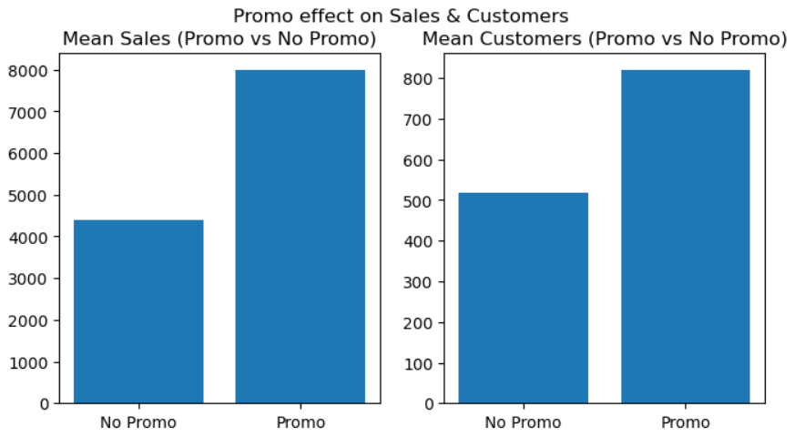
- Promo Impact: Stores running promotions generally record higher sales and more customers.
- Holiday Effect: Sales drop significantly during state holidays due to store closures.
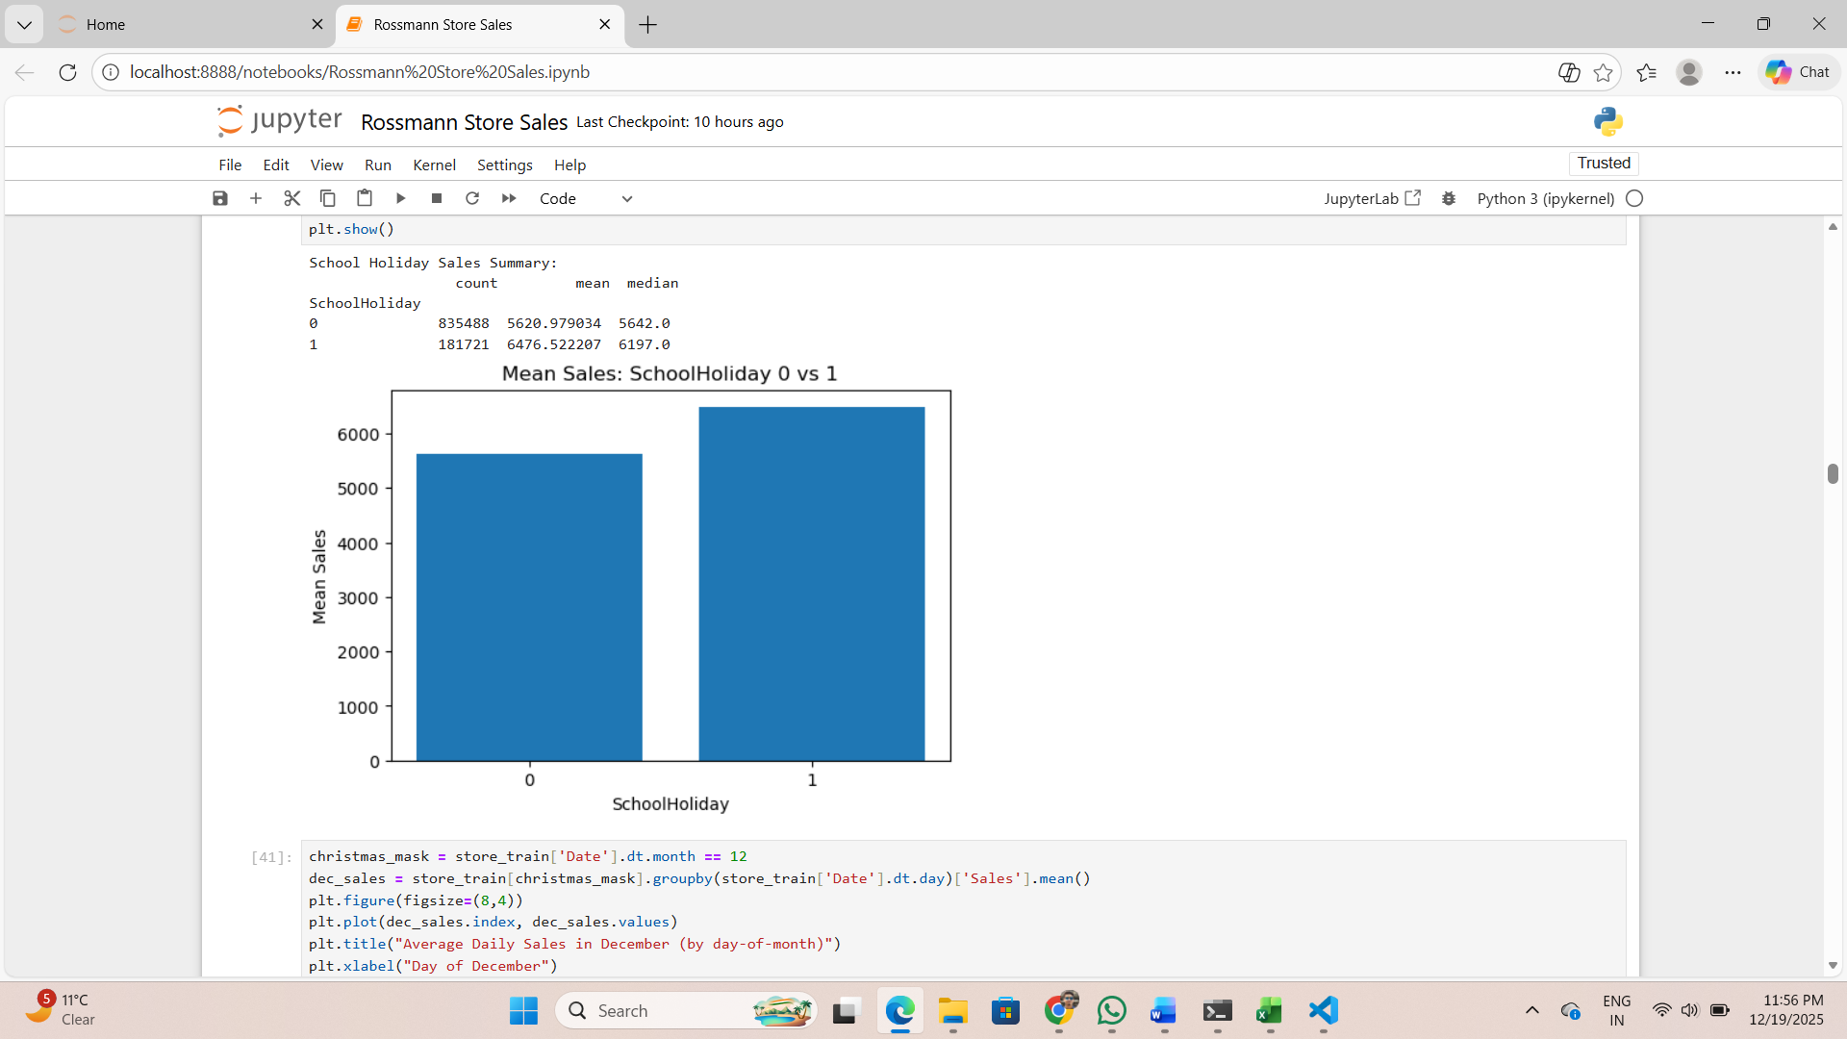
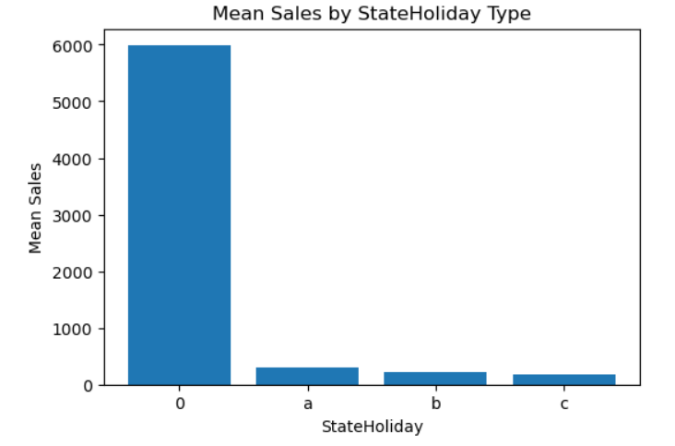
- Customers vs Sales: Strong positive correlation observed between number of customers and sales- 0.895.

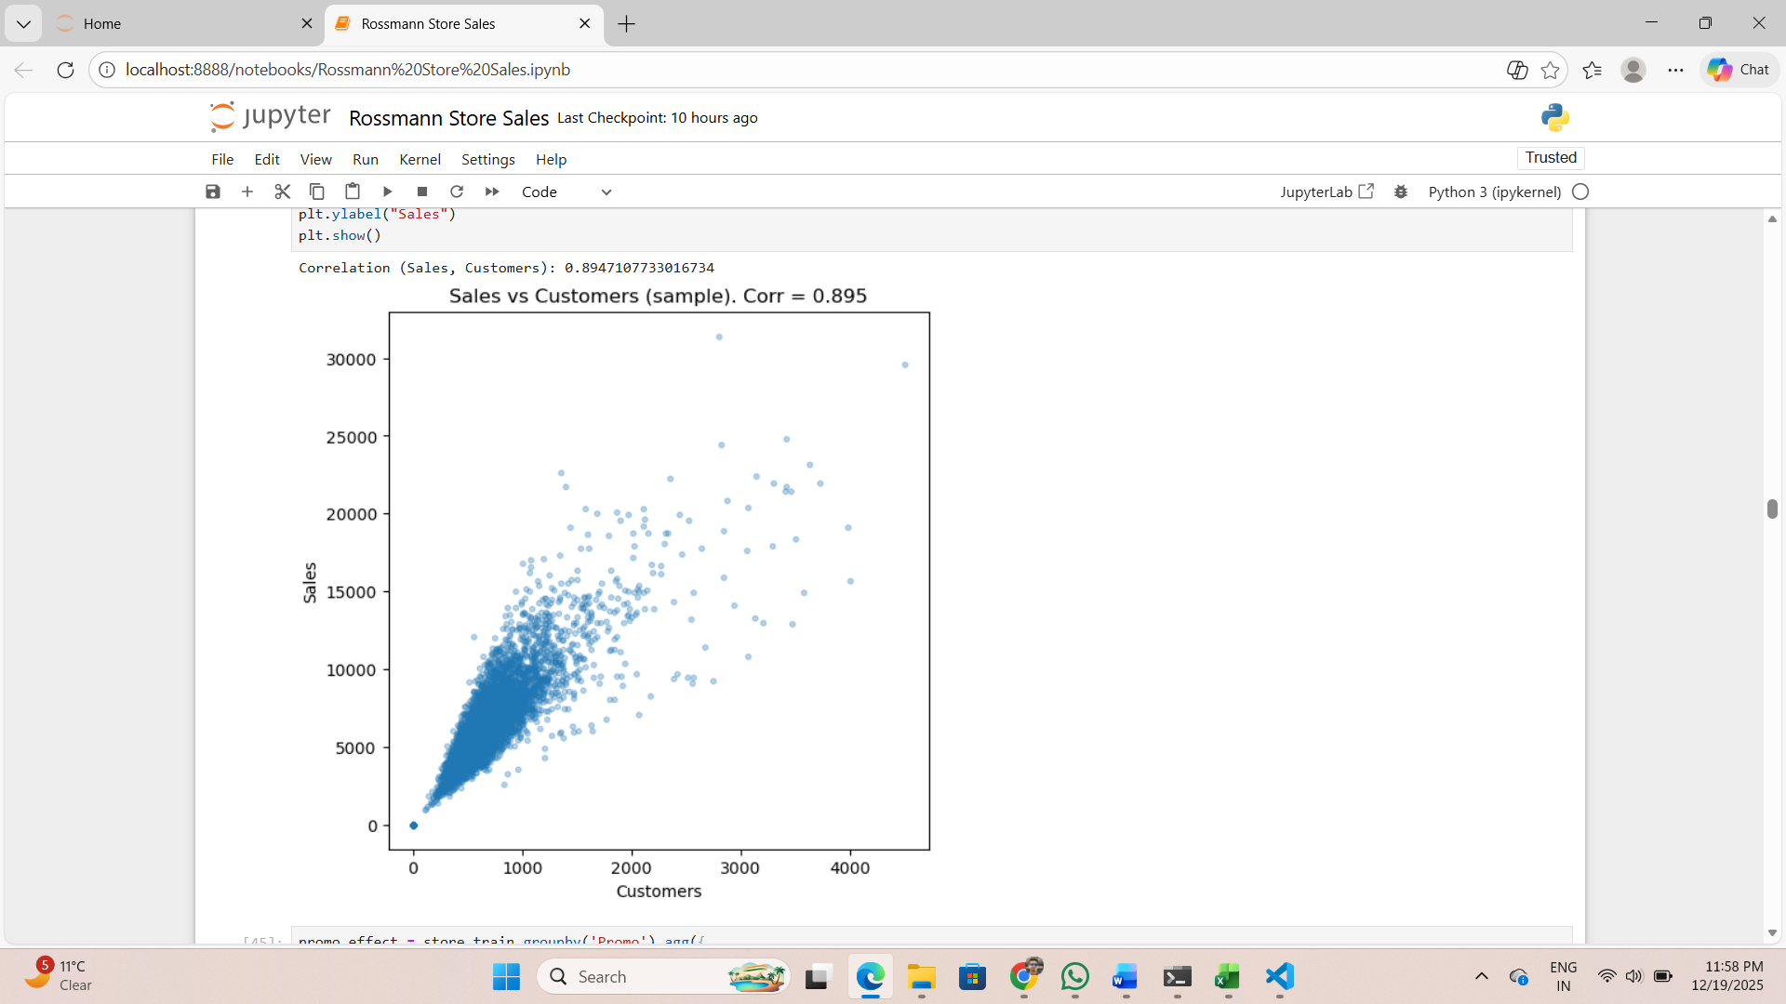

- Seasonality: Sales peak during Christmas and end-of-year periods.

Feature Engineering
Feature engineering played a crucial role in improving model performance.
Date-Based Features Extracted:
- Day of Week
- Is Weekend
- Is Holiday
- Month Start / Mid / End
- Week of Year
- Year
Other Transformations:
- Categorical features encoded using OneHotEncoding
- Missing values handled using SimpleImputer
- Numerical features scaled using StandardScaler
These features helped the model capture temporal patterns and seasonal trends effectively.

Machine Learning Approach
Model Used:
- Random Forest Regressor
Why Random Forest?
- Handles non-linear relationships well
- Robust to outliers
- Provides feature importance
- Performs well on tabular retail data
Pipeline Implementation:
A Sklearn Pipeline was used to:
- Handle preprocessing
- Apply transformations
- Train the model in a clean and reproducible way
This approach reduces data leakage and makes the model production-ready.
Loss Function Selection
The Root Mean Squared Logarithmic Error (RMSLE) was used as the evaluation metric.
Why RMSLE?
- Penalizes under-prediction more than over-prediction
- Handles skewed sales data
- Commonly used in sales forecasting problems
This makes RMSLE a suitable and interpretable loss function for this business problem.
RMSLE: 0.23583760470647216
MSE: 2358893.7760271872
An RMSLE score of 0.2358 indicates that the model predictions are reasonably close to the actual sales values.

Deep Learning Approach (LSTM)
To further improve forecasting accuracy, a Long Short-Term Memory (LSTM) model was implemented.
Steps Followed:
- Converted sales data into time-series format
- Checked for stationarity
- Applied differencing where required
- Created supervised learning data using sliding window technique
- Scaled data to range (-1, 1)
- Built a two-layer LSTM regression model
Why LSTM?
- Captures long-term dependencies
- Suitable for sequential and time-series data
- Performs well on sales forecasting tasks
The LSTM model showed promising results in capturing seasonality and trends compared to traditional ML models.

Model Evaluation and Feature Importance
Feature importance from the Random Forest model revealed that below features were among the most influential features affecting sales.

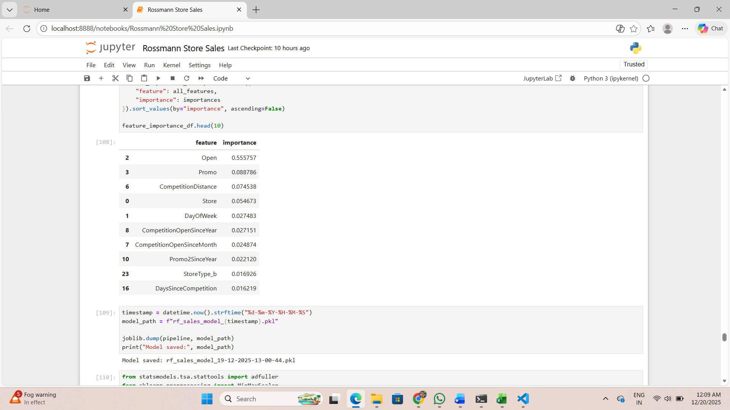

Model Serialization and MLflow
The trained models were serialized using joblib with timestamp-based naming for version control.
MLflow was used for:
- Tracking experiments
- Logging metrics
- Comparing different model versions
Due to repository file size restrictions, the trained model was stored externally and dynamically loaded during deployment.

Link- http://localhost:8501/

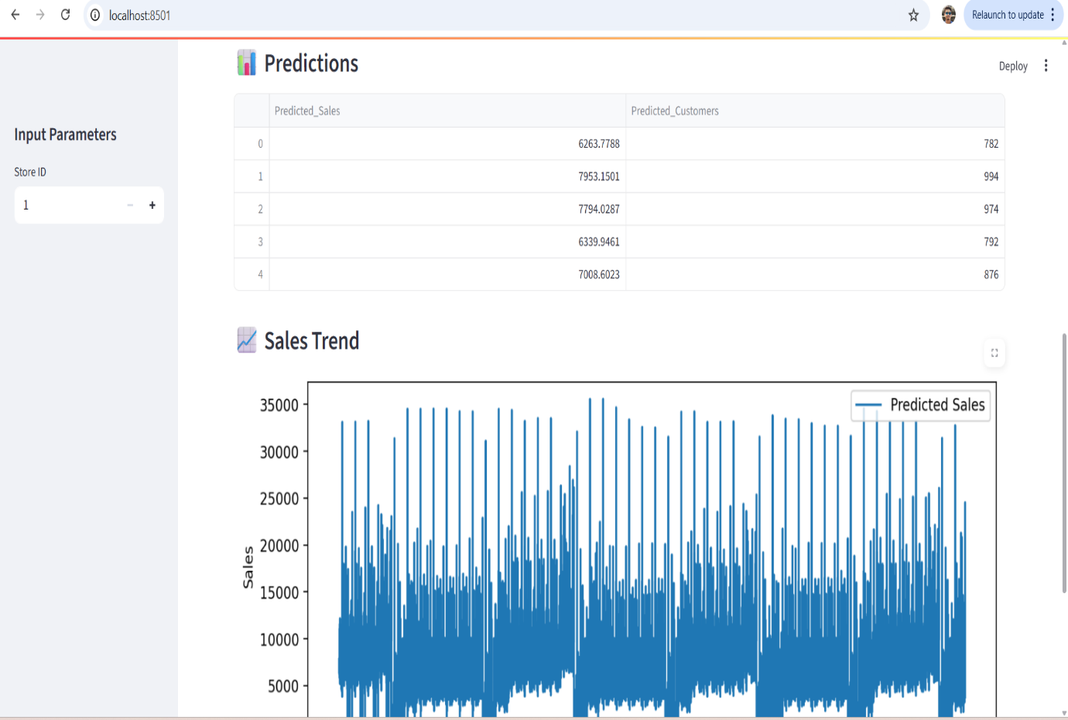

Deployment (Web Application)
A Streamlit-based web application was developed to serve predictions.
Features of the App:
- CSV file upload
- Automatic sales prediction
- Visualization of predicted sales
- Downloadable prediction results
This allows store managers and analysts to use the model without any technical knowledge.

Challenges and Solutions
Challenge:
- Large model file size restricted upload to GitHub
Solution:
- Hosted the model externally and loaded it dynamically at runtime
- This follows real-world MLOps best practices

Conclusion
This project demonstrates a complete end-to-end sales forecasting solution using both Machine Learning and Deep Learning techniques. By combining strong feature engineering, robust models, and a production-ready deployment, the system provides valuable insights and accurate sales predictions.
The deep learning LSTM model further enhanced forecasting capabilities by capturing time-series patterns, while the deployed application ensures real-world usability.

Future Enhancements
- Incorporate weather data
- Use advanced deep learning architectures
- Add confidence intervals to predictions
- Automate retraining with new data

  - Alankar Saxena

